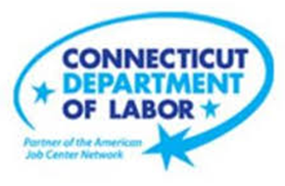

**NEW WEEKLY JOB POSTINGS FROM   
HELP WANTED ONLINE  
Office of Research**

**Week Ending August 27th, 2022: Revised Job Ad Counts Show Over The Week Increase**WETHERSFIELD, September 2nd, 2022 – During the week ending August 27th, there were 8,211 new postings, up 2,253 or +38% over the week. The Help Wanted Online data series was recently revised beginning in May 2022. The graph below illustrates the 12 months of new revised job ad totals (green line) and the old totals which were discontinued after the week ending August 20th, 2022 (shaded blue). Nineteen of twenty-one industries had increases over the week, The largest increases occurred in Health Care & Social Assistance (+660 new ads), Pro., Sci., & Tech. Services (+249 new ads), and Finance & Insurance (+228 new ads). Occupations with the largest over the week decreases include Registered Nurses (+223 new ads), Electrical Engineers (+61 new ads), and Statisticians (+59 new ads). The newly revised weekly job ads shows that the month of August averaged 7,626 new ads per week, which is above the July 2022 weekly average of 7,377 new ads.

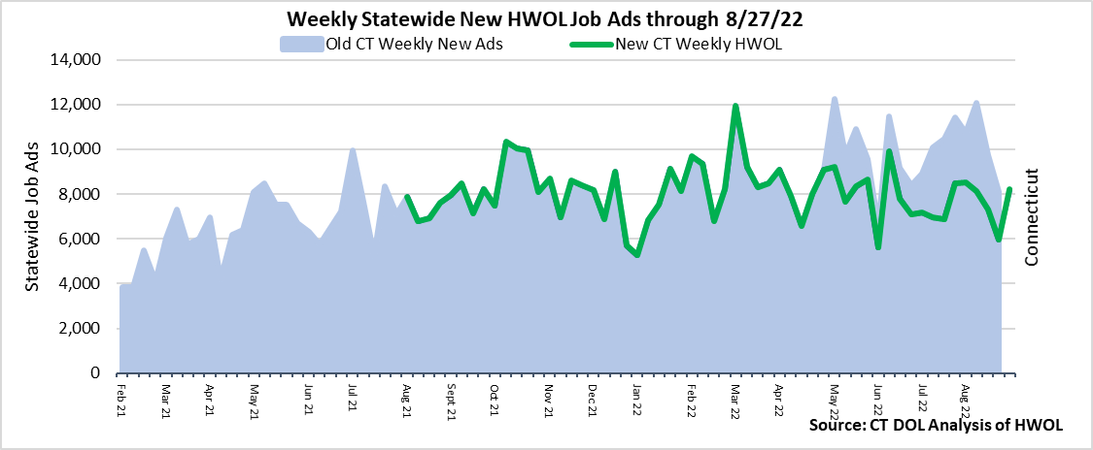  
**Industries** with the most new postings include Health Care & Social Assistance, Finance & Insurance, and Manufacturing.

**Occupations** with the most new postings include Registered Nurses, Retail Salespersons, and Wholesale & Manufacturing Sales Representatives.

**Employers** with the most new postings include Hartford Healthcare, The Staff Pad, and Parexel.

**The three industries with the most new job postings were:**

* **Health Care & Social Assistance** (1,819 new postings, +57% over the week)
* **Finance & Insurance** (741 new postings, +44% over the week)
* **Manufacturing** (682 new postings, +19% over the week)

  
 During the week ending August 27th, 2022, the total ad increase of +2,253 new ads or +38% is the net result of increases in 19 of 21 industries. Half of the weekly increase occurred in Health Care & Social Assistance (+660 new ads), Pro., Sci., & Tech. Services (+249 new ads), and Finance & Insurance (+228 new ads). Over 4 weeks, total new ads were down 308 new ads or -4%. 13 of 21 industries had 4-week declines, the largest occurred in Retail Trade (-111 new ads), Manufacturing (-100 new ads), and Administrative & Support (-58 new ads).   
  
 For more information on total job ads by industry for Connecticut and its labor market areas, see the monthly report available here: <https://www1.ctdol.state.ct.us/lmi/hwol.asp>

**New Job Postings by Occupation** 

**The occupations with the most new postings were:**

* Registered Nurses (+223 new postings, +96% over the week)
* Retail Salespersons (+26 new postings, +14% over the week)
* Wholesale & Manufacturing Sales Representatives (+47 new postings, +46% over the week)

**Employers with the Most New Job Postings**

Employers with the most new job postings during the week were mostly in Healthcare & Social Assistance, Finance & Insurance, and Retail Trade. The 25 employers shown above account for 18 percent of all new ads. 12 of 25 employers in the top 25 had over the week increases. The largest increases in the top 25 include Hartford Healthcare (+174 new ads), The Staff Pad (+156 new ads), and Parexel (+107 new ads). Over four weeks, 15 employers in the top 25 had increases and 10 had decreases. The largest four-week increase occurred at The Staff Pad (+156 new ads) and Parexel (+114 new ads), the largest four-week decrease occurred at Hartford Healthcare (-110 new ads).   
  
**What is HWOL?**The **Conference Board Help Wanted Online**® Data Series (HWOL) measures the number of new, first-time Online job postings and jobs reposted from the previous month for over 16,000 Internet job boards, corporate boards and smaller job sites that serve niche markets and smaller geographic areas. To view more HWOL data, go to: <https://www1.ctdol.state.ct.us/lmi/hwol.asp>